**What is business analysis?**

**Business analysis** is:” The practice of enabling change in an enterprise by defining needs and recommending solutions that deliver value to stakeholders” [1].

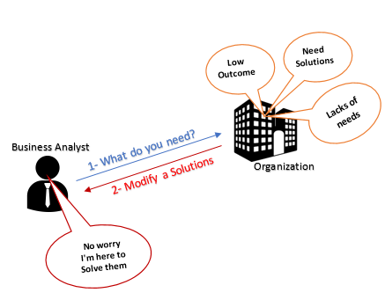

**Who is the Business Analyst?**

**Business Analysts "BA"** is who analyze the organization/business domain to documents this analyzing. Then asses the business model and its integration with technology.

To help & guide the processes, products, and services of business improvement and software through that data. [2]

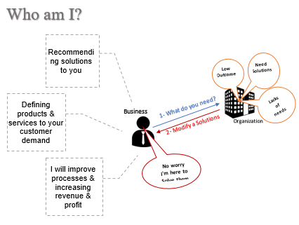

**What is the basic principle of BACCM?**

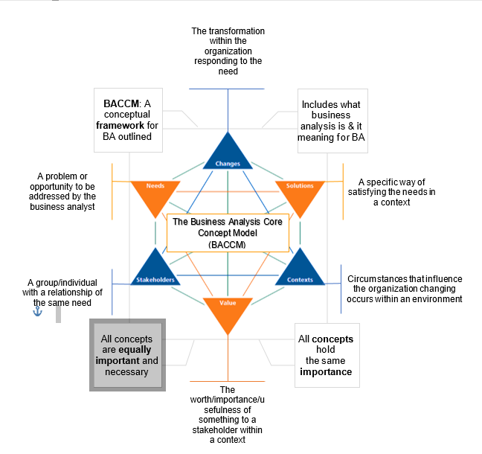

Figure 1 The Core concepts of BACCM [3]

**What is Requirements classification schema? With examples. [4]**

**Defining** the goals/objectives of the business at the organization (organization as a whole).

**Example:** A business rule which runs that process and that data

**Business Requirements**

**Describing** the **goals**/ objectives of a particular group within an organization.

**Example**: Suppliers (provide goods, material) , Project Manager (managing schedule, budget), User(real users of the project deliverables , require new features)

**Stakeholder Requirements**

**Describing** various **points** of the solution (A process/system solution) that must be met.

**Solution Requirements**

**Describing** any capabilities of the solution then do the transition of users/information from the current solution to the new solution has occurred.

**Example:** Updating the system or use new resources

**Transition Requirements**

**Describing** the **behavior** and information that the solution will manage.

**Example**: Prototype , A workflow diagram

**Functional Requirements**

**Describing** the **qualities** (Not describing what the solution must do) of the process/system.

**Example**: Performance, usability, compatibility

**Non-Functional Requirements**

**Categorize business analysis tasks within the six knowledge areas, noting the commonly used techniques for each field. [5]**

The tasks (Describing meaningful requirements and designs and assessing) that BA perform on proposed changes to requirements and designs

**Techniques**: Glossary, Item tracking.

**Requirements Life Cycle Management**

The assessment of the available to select the most appropriate solution to implement the requirements

**Techniques**: Process Analysis, Acceptance & Evaluation

**Solution Evaluation**

Describing the BA work that must be performed in order to identify a need for strategic/tactical importance enabling the enterprise to address that need

**Techniques**: Business Case, Risk Analysis.

**Strategy Analysis**

Activities which a business analyst should follow to determine the efforts involved in the future.

**Techniques**: Functional Decomposition, Interface Analysis

**Business Analysis Planning and Monitoring**

It’s important to gather the requirements from the available sources and elicit from them.

**Techniques**: brain storming, interviewing, Experiment (prototyping), Research ( Market Analysis).

**Elicitation and Collaboration**

Perform in order to manage/maintain the requirements and design information from inception to retirement.

**Techniques**: user (Use Case), Process (Process Modelling), Data (Data Modelling)

**Requirements Analysis and Design Definition**

**~*~**

[1] Brûlé and Brûlé, "WHAT IS BUSINESS ANALYSIS?", BA Times, 2019. [Online]. Available: https://www.batimes.com/articles/what-is-business-analysis.html. [Accessed: 02- Jul- 2019].

[2] "Business analyst", En.wikipedia.org, 2019. [Online]. Available: https://en.wikipedia.org/wiki/Business_analyst. [Accessed: 03- Jul- 2019].

[3]B. Management, T. (BACCM) and R. Wijetunge, "The Business Analysis Core Concept Model (BACCM)", KnowledgeHut Blog, 2019. [Online]. Available: https://www.knowledgehut.com/blog/business-management/the-business-analysis-core-concept-model-baccm. [Accessed: 03- Jul- 2019].

[4]"Describe the basic classification of requirements as defined by the BABOK (v2.0). > Business Analyst Community & Resources | Modern Analyst", Modernanalyst.com, 2019. [Online]. Available: https://www.modernanalyst.com/Careers/InterviewQuestions/tabid/128/ID/1538/Describe-the-basic-classification-of-requirements-as-defined-by-the-BABOK-v20.aspx. [Accessed: 03- Jul- 2019].

[5]"6 knowledge Areas Business Analyst should know it well.", Business Borderlines, 2019. [Online]. Available: https://businessborderlines.com/business-analyst-knowledge-areas/. [Accessed: 03- Jul- 2019].